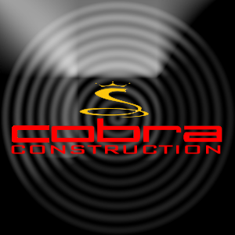

COBRA CONSTRUCTION

15997 woodbine circle

Vernon hills, il, 60061